Name:________________________ Age of Exploration Map
Draw in the routes of the following explorers using a different color or pattern for each explorer. Label the following locations also. Make a key (draw the color you used next to each explorer’s name): 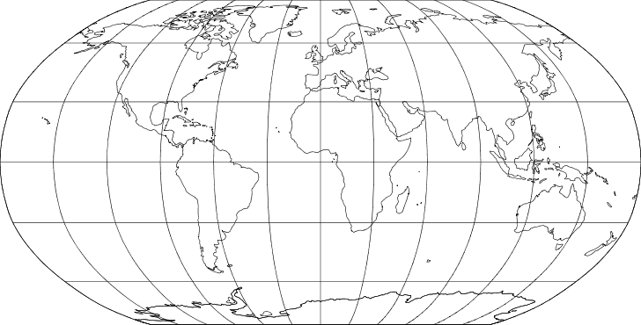
C. Columbus B. Diaz F. Pizarro F. Magellan H. Cortez
A.Vespucci V. DeGama Cape of Good Hope East Indies Silk Road

