Garden Animals to the Rescue
Each of the garden animals has decided to start a business in India’s Segowlee Cantonment, ranging from landscaping to security.
You own an advertising agency that has been charged with creating a flyer for one of these local businesses. Choose a character/business name from below (or come up with your own) and create an ad persuading people to use their services:
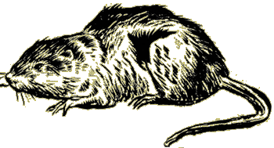
+Rikki-tikki’s Security Pros +Nag’s Self Defense Lessons +Nagaina’s Babysitting Services
+Darzee and Lady Landscaping Inc. +Karait’s Hypnotherapy Lessons +Chuchundra’s Support Group for Terrified Beasts

Your flyer should include:
1. Your animal’s business name (large/bold!).
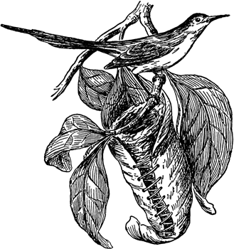
2. A slogan* specific to the services your animal provides based on the CHARACTERISTICS of your animal (use the book). This slogan should be persuasive enough so that English families would call upon the company for their services. *a slogan tells the customer what it is that your business does
3. An image/logo appropriate for your animal’s business.
4. Contact information… how can people book your services?
5. Some background images that display the character in a setting that relates to the story
6. Your entire flyer should be in COLOR.
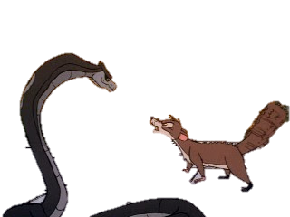
Business Name
Contact Info or other important info
222-4444
Slogan here!
Something catchy!

