Station # 1 Class Copy

The following documents provide information about nationalism. Examine the documents carefully, and answer the questions that follow on your answer sheet.

Document 1

This excerpt is from the ‘Levee en Masse’, French Revolution, August 23, 1793.
“The young men shall go forth to battle; the married men will make arms and transport food; the women will make tents, uniforms, and will serve in the hospitals; the children will prepare lint from old linens; the old men will gather in public places to raise the courage of the warriors, to excite hatred of kings and to preach the unity of the Republic.”

- What country is this excerpt originally from?

- The term ‘levee en masse’ translates to mean ‘a mass uprising’. How did levee en masse affect the French people?

- The government created the idea of ‘levee en masse’ during the French Revolution. How does this action promote nationalism?

Document 2

The political cartoon below illustrates the “dangerous” side of nationalism.

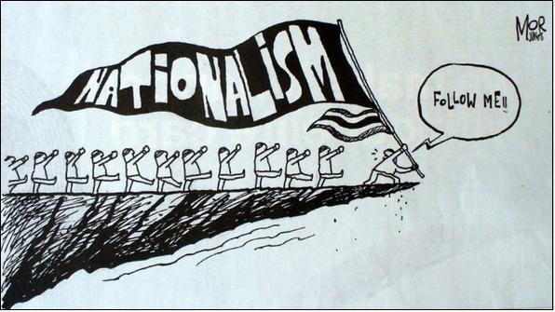

- According to this political cartoon, what is a danger of nationalism?

Station # 2 Class Copy

The following documents provide information about nationalism. Examine the documents carefully, and answer the questions that follow on your answer sheet.

Document 3

The ‘Marseillaise’ is the French national anthem.
Arise, children of the fatherland,
Our day of glory has arrived.
Against us cruel tyrants.
Have raised their bloody flag.
Do you hear in the countryside
Their fierce hired soldiers?
They come almost into your arms
To attack your children and your fields.

Chorus
To arms, citizens!
Form your battalions!
March on, march on,
To liberty or death!

- What does the French national anthem urge its citizens to do?

- Does a national anthem unify or discourage unity? Do national anthems promote nationalism? How?

Document 4

Giuseppe Garibaldi, the “sword” of Italian unification, added the southern Kingdom of the Two Sicilies to Italy in 1861. He describes his “Red Shirts” with these words.
“O noble Thousand!...I love to remember you!...Where any of our brothers are fighting for liberty, there all Italians must hasten!-such was your motto. Let him who loves his country in his heart, and not with his lips only, follow me.

- What does Garibaldi mean by ‘…[he] who loves his country in his heart, and not with his lips only, follow me’?

- What is Garibaldi trying to accomplish in this speech?

Station # 3 Class Copy

The following documents provide information about nationalism. Examine the documents carefully, and answer the questions that follow on your answer sheet.

Document 5

This excerpt is from Count Cavour who was named prime minister of Piedmont-Sardinia in 1852. As a diplomat, he provided the “brains” of Italian unification.
“We ardently wish to free Italy from foreign rule....We want to drive out foreigners not only because we want to see our country powerful and glorious, but because we want to elevate the Italian people in intelligence and moral development.”

- Create a definition for the word ‘ardently.’ (Hint- use context clues to help you)

- What actions do you think Cavour is promoting? How will he achieve his goals?

Document 6

This illustration shows the effect of nationalism among the subject nationalities of the Austro-Hungarian Empire.
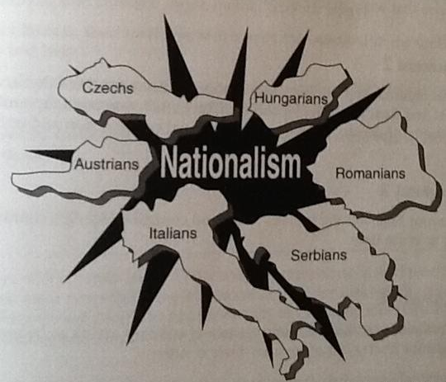

- Based on this illustration, what was the effect of nationalism on the Austro-Hungarian Empire?

