Name:_______________________
Propaganda Posters: Digging deeper
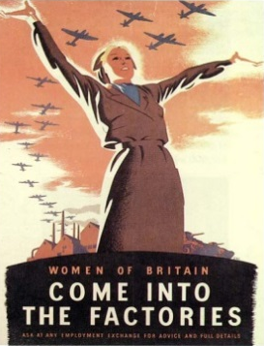
Answer the questions and decide which propaganda technique is being used in each ad.
- Why is this woman standing so proud and tall?
_________________________________________________________________________________________________________________________________________________________Which technique(s) is being used:

- What does ‘we can do it’ mean?
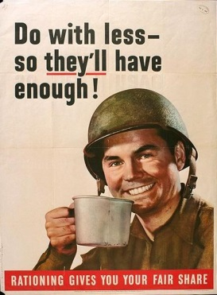
_________________________________________________________________________________________________________________________________________________________ Which technique(s) is being used:

- Do with less of what? Who does it help?
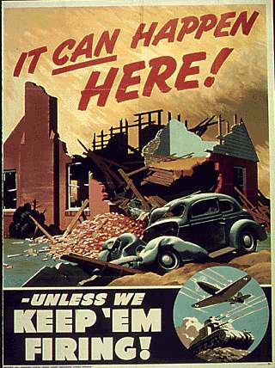
_________________________________________________________________________________________________________________________________________________________ Which technique(s) is being used:

- What do we need to keep firing? For what reason?
_________________________________________________________________________________________________________________________________________________________ Which technique(s) is being used:

- How can food be a weapon?
________________________________________________________________________________________________________________________________________________________________ Which technique(s) is being used:
- Why would digging make us victorious?
_________________________________________________________________________________________________________________________________________________________
Which technique(s) is being used:

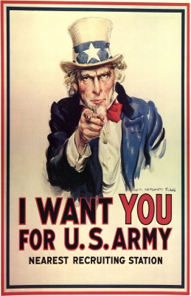
- Why is this poster powerful?
_________________________________________________________________________________________________________________________________________________________ Which technique(s) is being used:

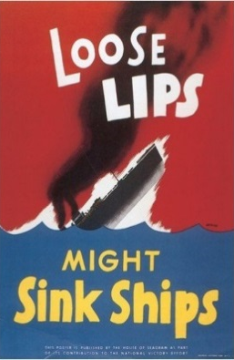
- This poster uses a rhyme, what does it mean?
_________________________________________________________________________________________________________________________________________________________ Which technique(s) is being used:
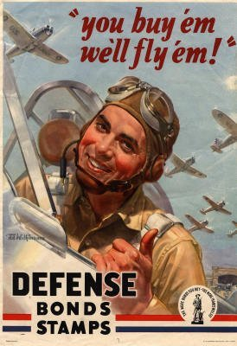
- This poster is trying to raise money, what for and why?
_________________________________________________________________________________________________________________________________________________________ Which technique(s) is being used:
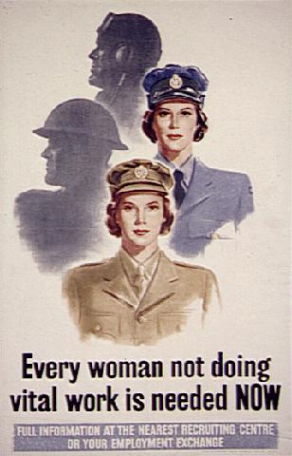
- What were they needed for?
_________________________________________________________________________________________________________________________________________________________ Which technique(s) is being used:
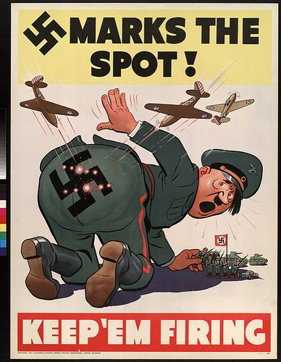
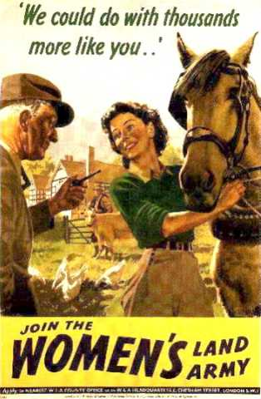
- Keep who firing? How is humor being used here?
_________________________________________________________________________________________________________________________________________________________ Which technique(s) is being used:
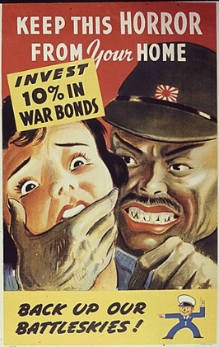
- Who is this ad targeting? How are they supposed to feel after they see it?
_________________________________________________________________________________________________________________________________________________________
Which technique(s) is being used:

