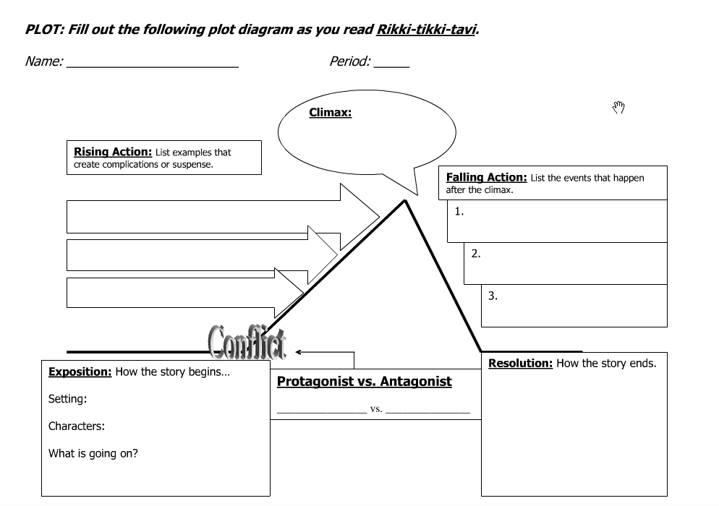
Go back to the part of the story where Rikki Tikki follows Nagiana into the burrow. Create an alternate ending narrated in the FIRST PERSON, from either Rikki Tikki’s or Nagiana’s point-of-view.

___________________________________________________________________

___________________________________________________________________

___________________________________________________________________

___________________________________________________________________

___________________________________________________________________

___________________________________________________________________

___________________________________________________________________

___________________________________________________________________

___________________________________________________________________

___________________________________________________________________

___________________________________________________________________

___________________________________________________________________

___________________________________________________________________

