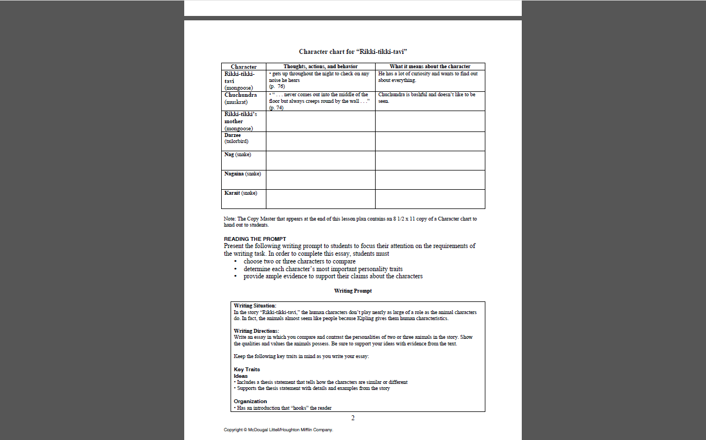Name:_____________________