NAME:____________________ PD:_____
Seedfolks unit Packet
Rubric/checklist:
____ 4 character sheets completed (20 pts)
____ Seed packet completed (20 pts)
____ Quilt square completed (see rubric) (20 pts)
____ Character chart completed (20 pts)
____ Class seminar (20 pts)

All parts of the project are due _________________.

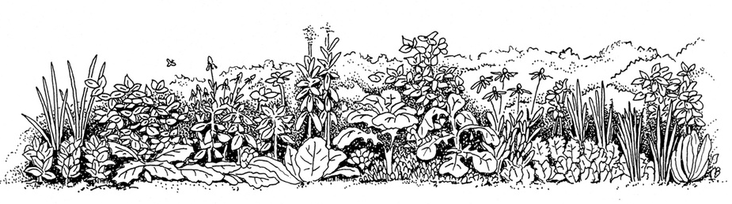

Exploring the Folks in Seedfolks
Fill out this sheet for FOUR of the characters in Seedfolks. You may pick whichever 4 you would like! You may need to use your inferencing skills to fill in some of the information if it is not explicitly given in the chapter.
Name: _________________________Age: _______ Male/female:________________
Ethnicity: ______________________________________ First Language: __________________
What is his/her closest connection to farming?

What is his/her “story”? What conflict, problem, or loss does he or she face? How does his/her interaction with the garden help this character?

What is the character’s role in the garden? (founder, participant, problem-solver, observer?)

What do you learn about the community and the garden through your character?

What about your character’s “voice”? Can you hear he/she speaking? Does he/she have an accent? How do you know?

What do you predict will happen next in this character’s life?

Write one sentence or quote (word for word) from the chapter that describes this CHARACTER perfectly.

Write one sentence or quote (word for word) from the chapter that describes the CONFLICT perfectly.
Name: _________________________Age: _______ Male/female:________________
Ethnicity: ______________________________________ First Language: __________________
What is his/her closest connection to farming?

What is his/her “story”? What conflict, problem, or loss does he or she face? How does his/her interaction with the garden help this character?

What is the character’s role in the garden? (founder, participant, problem-solver, observer?)

What do you learn about the community and the garden through your character?

What about your character’s “voice”? Can you hear he/she speaking? Does he/she have an accent? How do you know?

What do you predict will happen next in this character’s life?

Write one sentence or quote (word for word) from the chapter that describes this CHARACTER perfectly.

Write one sentence or quote (word for word) from the chapter that describes the CONFLICT perfectly.

Name: _________________________Age: _______ Male/female:________________
Ethnicity: ______________________________________ First Language: __________________
What is his/her closest connection to farming?

What is his/her “story”? What conflict, problem, or loss does he or she face? How does his/her interaction with the garden help this character?

What is the character’s role in the garden? (founder, participant, problem-solver, observer?)

What do you learn about the community and the garden through your character?

What about your character’s “voice”? Can you hear he/she speaking? Does he/she have an accent? How do you know?

What do you predict will happen next in this character’s life?

Write one sentence or quote (word for word) from the chapter that describes this CHARACTER perfectly.

Write one sentence or quote (word for word) from the chapter that describes the CONFLICT perfectly.

Name: _________________________Age: _______ Male/female:________________
Ethnicity: ______________________________________ First Language: __________________
What is his/her closest connection to farming?

What is his/her “story”? What conflict, problem, or loss does he or she face? How does his/her interaction with the garden help this character?

What is the character’s role in the garden? (founder, participant, problem-solver, observer?)

What do you learn about the community and the garden through your character?

What about your character’s “voice”? Can you hear he/she speaking? Does he/she have an accent? How do you know?

What do you predict will happen next in this character’s life?

Write one sentence or quote (word for word) from the chapter that describes this CHARACTER perfectly.

Write one sentence or quote (word for word) from the chapter that describes the CONFLICT perfectly.

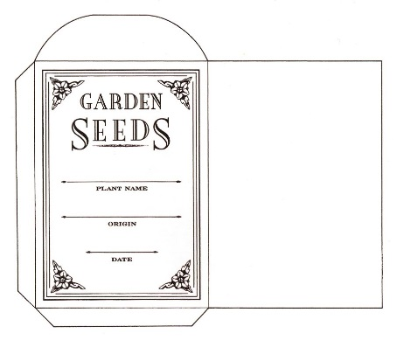
SEEd Packet activity
Directions:
From the seed packet template, cut out along the solid lines, cutting out 2 blank, flat seed packets. One packet is for you, one is for your neighbor.
You will flip over the packet, and draw on the side WITHOUT the words “fold along the dotted lines”.

FRONT OF SEED PACKET (10 pts):
_____ Choose ONE of the characters you wrote already. Use the book to find their picture.
_____ Using colored pencils, markers, or crayons, decorate the front of your seed packet with a drawing of the character, and the fruit or vegetable this character grew in the story.
_____ Don’t forget to write/draw the character’s name somewhere on the front.

BACK OF THE SEED PACKET (10 pts):
In some way (writing, bullets, drawing, or a combo) include the following on the back of your seed packet
____ Country or city the character lived in before moving to the apartment building in Ohio
____ Personality trait of the character
____ Time of year these seeds were planted, if mentioned in the chapter
____ Why the seeds were planted, if a reason was given
____ What the main character planned to do with the fruits or vegetables once harvested, if mentioned.

Quilt Square Activity
Design a square for the Seedfolks quilt that:
- represents your character and their part of the garden
- his or her culture
- what s/he grew in the garden
- what/how they reclaimed a loss
- whatever else is significant in the character’s story
- personality traits that define the character
This is like a bigger, prettier, version of the seed packet. Sketch it out here; you’ll be given your quilt square when you show me your draft. All of our final squares will be used to create a giant, class-wide quilt. So, do a great job!
Quilt Square Rubric

