Transatlantic Slave Trade RAFT Name:_________
Using your Transatlantic Slave Trade notes, the back of this sheet, and information from the video, you will create three diary entries (1st person POV) of the slave trade and middle passage in which you describe the inhumanity of the slave trade and middle passage.

Choose your role and begin planning your RAFT using the attached plan sheet

Role | Audience | Format | Topic
Slave ship captain | Person from 2015 who does not know anything about the slave trade or middle passage | 3 diary entries—first hand account | slave trade/middle passage – use your notes and back of this sheet
African slave | Person from 2015 who does not know anything about the slave trade or middle passage | 3 diary entries—first hand account | slave trade/middle passage – use your notes and back of this sheet
Slave ship itself | Person from 2015 who does not know anything about the slave trade or middle passage | 3 diary entries—first hand account | slave trade/middle passage – use your notes and back of this sheet
Board on which a slave is forced to lay in the hold of the ship | Person from 2015 who does not know anything about the slave trade or middle passage | 3 diary entries—first hand account | slave trade/middle passage – use your notes and back of this sheet
Chain/shackles used to restrain slaves in the hold of the ship | Person from 2015 who does not know anything about the slave trade or middle passage | 3 diary entries—first hand account | slave trade/middle passage – use your notes and back of this sheet
Rubric:
___ Completed plan sheet (10 pts)
___ Three dated diary entries (dates should be appropriate to slave trade years) (10 pts)
___ At least 7-10 facts from notes/back of this page incorporated into your diary entry (30 pts)
___ Personal opinion/thoughts/narrative elements that describe your day in detail (40 pts)
___ Your role is clear/obvious and you wrote from the first person (I/me/my) (10 pts)
WRITE OR TYPE YOUR RAFT ON SEPARATE PAPER AND STAPLE TO THIS SHEET. DUE FRIDAY.
Slave Trade Frequently Asked Questions and Answers
Use these to help fill your journal entries with as much accurate details as possible.

- How much space did the average captive have on a slave ship? Every slave, whatever his size might be, was found to have only five feet and six inches in length, and sixteen inches in breadth, to lie in. The floor was covered with bodies stowed or packed according to this allowance: but between the floor and the deck or ceiling were often platforms or broad shelves in the mid-way, which were covered with bodies.

- When captives were brought to the African ports, they were bound together, two by two. Were they also tethered, in some manner, aboard ship? The men were chained two and two together by their hands and feet, and were chained also by means of ring-bolts, which were fastened to the deck. They were confined in this manner at least all the time they remained upon the coast, which was from six weeks to six months as it might happen.
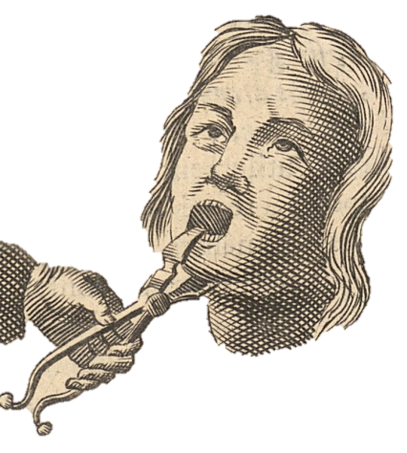
- If they were captured to provide free labor, Africans needed nourishment. What did they eat? Their allowance consisted of one pint of water a day to each person, and they were fed twice a day with yams and horsebeans (kind of like lima beans). Some of the captives refused to eat, wishing to die rather than to live in such horrific conditions. When that happened, slavers would force-open their mouths with a device (called a speculum oris) which looked like an instrument of torture.
- Confined in cramped quarters, how did the captives keep their bodies limber? After meals they jumped up in their irons for exercise. This was so necessary for their health, that they were whipped if they refused to do it.

- Were captives allowed to breathe fresh air, or did they spend most of their time below deck? They were usually fifteen and sixteen hours below deck out of the twenty-four. In rainy weather they could not be brought up for two or three days together. If the ship was full, their situation was then distressing. They sometimes drew their breath with anxious and laborious efforts, and some died of suffocation.
- It is said one could smell an approaching slave ship ten miles away, so horrific were its onboard conditions.

R.A.F.T. PLAN SHEET (10 pts)
Role: ___________________________ Name (if you chose a person): ______________________
Audience: ___________________________________________________________________
Date 1 (be sure it’s from the slave trade years): _______________________
Date 2 (be sure it’s from the slave trade years):________________________
Date 3 (be sure it’s from the slave trade years): ________________________
7-10 facts that you will include in your entries:
________________________________________________________________________________
________________________________________________________________________________
________________________________________________________________________________
________________________________________________________________________________
________________________________________________________________________________
________________________________________________________________________________
________________________________________________________________________________
________________________________________________________________________________
________________________________________________________________________________
________________________________________________________________________________
________________________________________________________________________________
________________________________________________________________________________
________________________________________________________________________________

