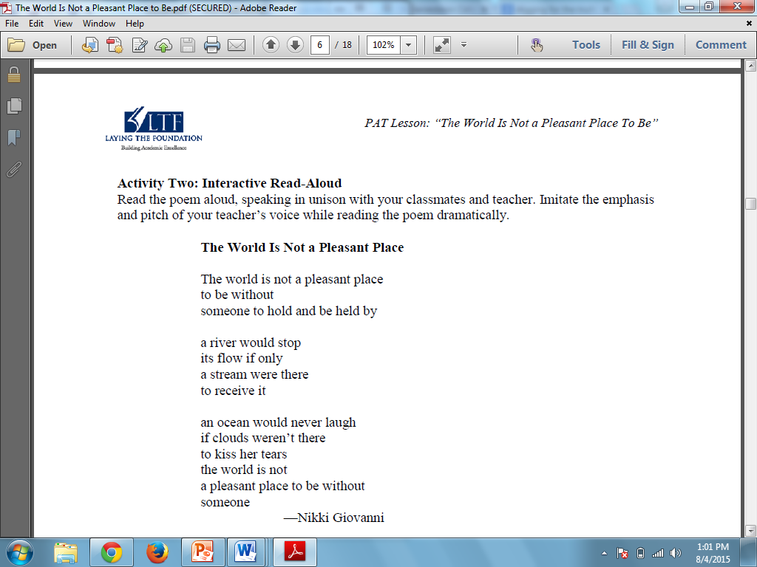

**NAME:______________________________**

Annotate stanza 1… put it into your own words:

Annotate stanza 2… put it into your own words:

Annotate stanza 3… put it into your own words:

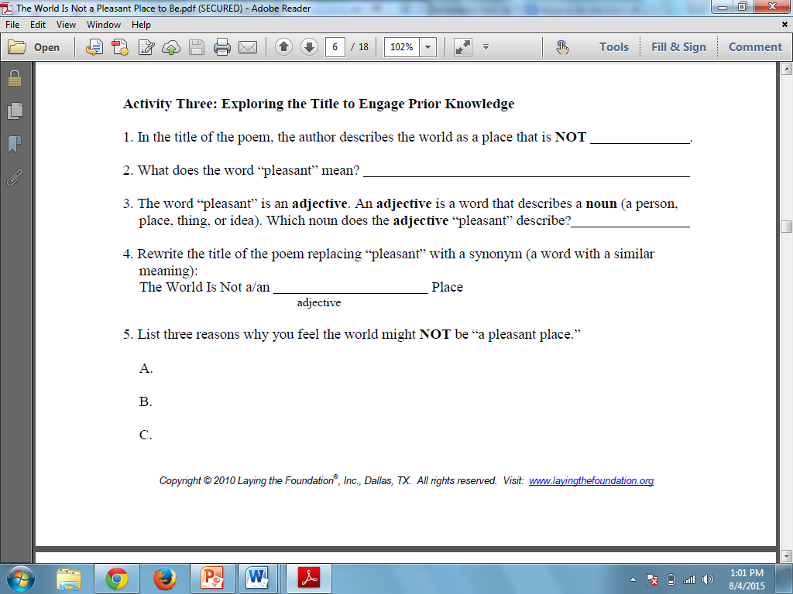

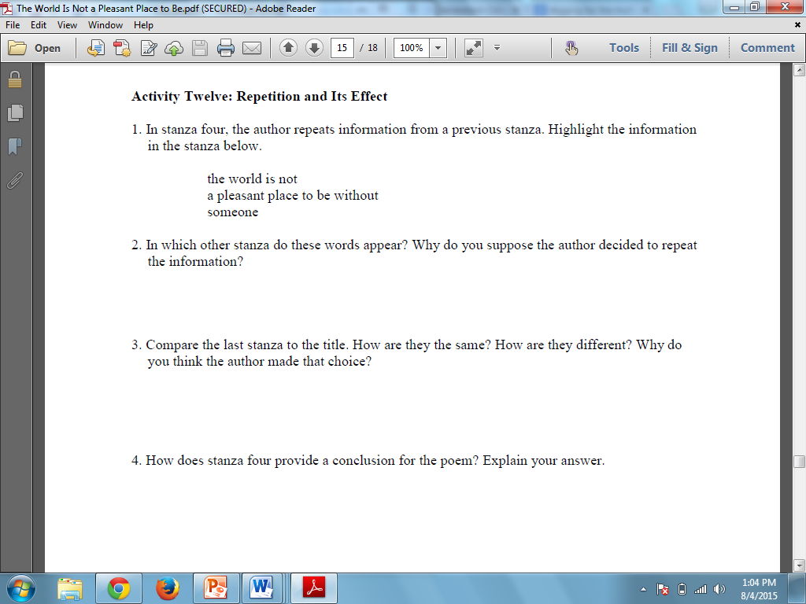Repetition and its effects

