Name:____________
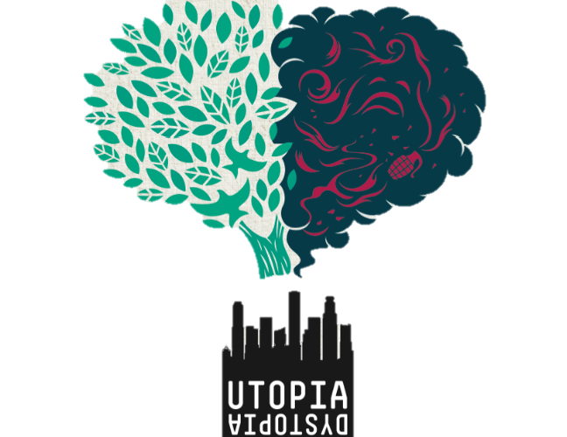
Utopia vs. Dystopia Notes

Utopia: An ideally perfect place, an impractical idealistic scheme
a. Varieties of Utopia
- Ecological Utopia
- Economic Utopia
- Political Utopia
- Religious Utopia
- Science and Technology Utopia

b. Ecological Utopia
- A traditional way of life that is more in harmony with nature.
- An organic way of life

c. Economic Utopia
- an equal distribution of goods, frequently with the total abolition of money, and citizens only doing work which they enjoy and which is for the common good, leaving them with ample time for the cultivation of the arts and sciences.

d. Political Utopia
- World Peace, Global Oneness
- Everyone getting along regardless of race, culture, political beliefs.
- A world without war.

e. Religious Utopia
- Harmony
- Peace
- Understanding
- Enlightenment

f. Science and Technology Utopia
- Set in the future
- Utopian Living Standards: absence of death and suffering, changes in human nature and the human condition (Star Trek)

WHAT IS YOUR UTOPIA?! Which category does it fall into?

Dystopia: An imaginary place or state in which the condition of life is extremely bad, as from deprivation, oppression, or terror.
Varieties of Dystopia
- Society
- Social Groups
- Nature
- Politics
- Economics

- Society
Examples:
  - Class System
  - People referred to as numbers rather than names
  - People are cloned so there are several of the same people, they are uniform and lose individuality (Brave New World)
  - People required to “not excel” and lose their competence
- Social Groups
Examples:
  - Concept of religion under attack
  - Concept of families no longer exists
- Nature
Examples:
  - Settings of dystopias are frequently urban
  - Separate all characters from any contact with nature
  - People are conditioned to be afraid of nature
- Politics
Examples:
  - Governing class is evil or shallow
  - Negative consequences, oppressive
  - Pessimistic views of governing class – brutal, uncaring
- Economics
Examples:
  - Black markets for goods that are difficult to get
  - Governing class controls everything
  - Big businesses have control and are corrupt

MOVIE CLIPS: Write which category(ies) of dystopia each movie would fit into:
- THE LORAX____________________________________________________
- WALL E _______________________________________________________
- HUNGER GAMES _______________________________________________
- PLEASANTVILLE ______________________________________________
- DIVERGENT ___________________________________________________

